
Henry Edward WOODS
Parole Violations - Aggravated Assault w/Weapon
Failure to Appear – Synthetic Narcotics
REGISTERED SEX OFFENDER/VIOLENT TENDENCIES

ALIAS(ES): “Woodsy” |     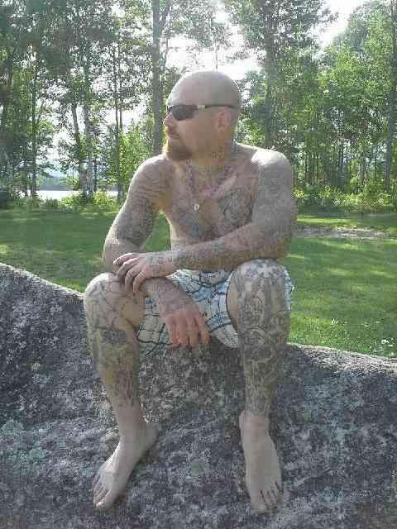
SEX: Male
RACE: White

DATE OF BIRTH: January 29, 1984 (36)
PLACE OF BIRTH: MA

HEIGHT: 5’10”
WEIGHT: 185 LBS
EYES: Brown
HAIR: Brown/Bald

SCARS/MARKS/TATTOOS: SC L Arm
TAT Chest-
TAT Abdom – “White Trash”
TAT L & R Arms–Full Sleeve
TAT R & L Legs-Full Sleeve
TAT Neck

FBI# 924935RB8
FID#: 11134585
NIC#: W461082128
W241139716

WARRANT(s) ISSUED: NH Parole Board
Carroll County
DATE OF WARRANT(s): May 29, 2020
June 12, 2020
The District of New Hampshire - New Hampshire Joint Fugitive Task Force is attempting to locate and arrest fugitive Henry Edward WOODS. WOODS is wanted on two warrants including a Parole Violation warrant stemming from his original conviction and sentence for aggravated assault with a weapon and a Carroll County warrant for Failing to Appear on a narcotics charge. WOODS is a registered sex offender whose last known address is Laconia, NH, but his current whereabouts are unknown. WOODS is required to register as a sex offender due to a 2004 conviction for sexual assault.

If you see someone who resembles WOODS, please contact the U.S. Marshals Fugitive Task Force, or your local police.

WEB-TIP-QR Code

DO NOT ATTEMPT TO APPREHEND THIS PERSON YOURSELF. REPORT ANY INFORMATION TO THE NEAREST USMS DISTRICT OFFICE at (603) 225-1632, or call 1-877-WANTED-2, or submit a WEB-TIP, or TEXT NHTIP with any information to TIP411.

Local Contact: Deputy US Marshal, Dan Dempsey --- (603) 225-1632

